**Day 2@**

### **🌈 JavaScript Color Generator -Explained**

**1️⃣ Why a changeColor() function?  
 Keeps logic separate from HTML, reusable & cleaner.**

**2️⃣ Math.random()  
 Generates a random number (0–1) → core for random color logic.**

**\3️⃣ Why 16777215?  
 It’s the max decimal for #FFFFFF in hex – full 24-bit color range.**

**4️⃣ .toString(16)?  
 Converts decimal to hex string – essential for color codes.**

**5️⃣ document.body.style.backgroundColor  
 Direct access to modify the page’s background color dynamically.**

**6️⃣ Using getElementById()  
 To update the visible hex code on screen – targets specific element.**

**7️⃣ Why padStart(6, '0')?  
 Ensures valid 6-digit hex – short values = incomplete colors!**

**8️⃣ .innerText vs .innerHTML vs .textContent  
 Each behaves slightly differently; use based on context and security.**

**9️⃣ Want RGB instead of hex?  
 Generate 3 random values (0–255) and format: rgb(r, g, b).**

**🔟 Why bother building this?  
 Tiny projects teach DOM, functions, and interactivity – the basics behind every powerful web app.**

🎯 Just finished breaking down this fun snippet —

#JavaScript #WebDev #ColorGenerator

**Just built a simple random background color generator using JavaScript! Here's how it works and what I learned 👇**

**https://github.com/hitarth2123/SEM2/tree/main/Sprint2/Javascript%20/Day2/Project1**

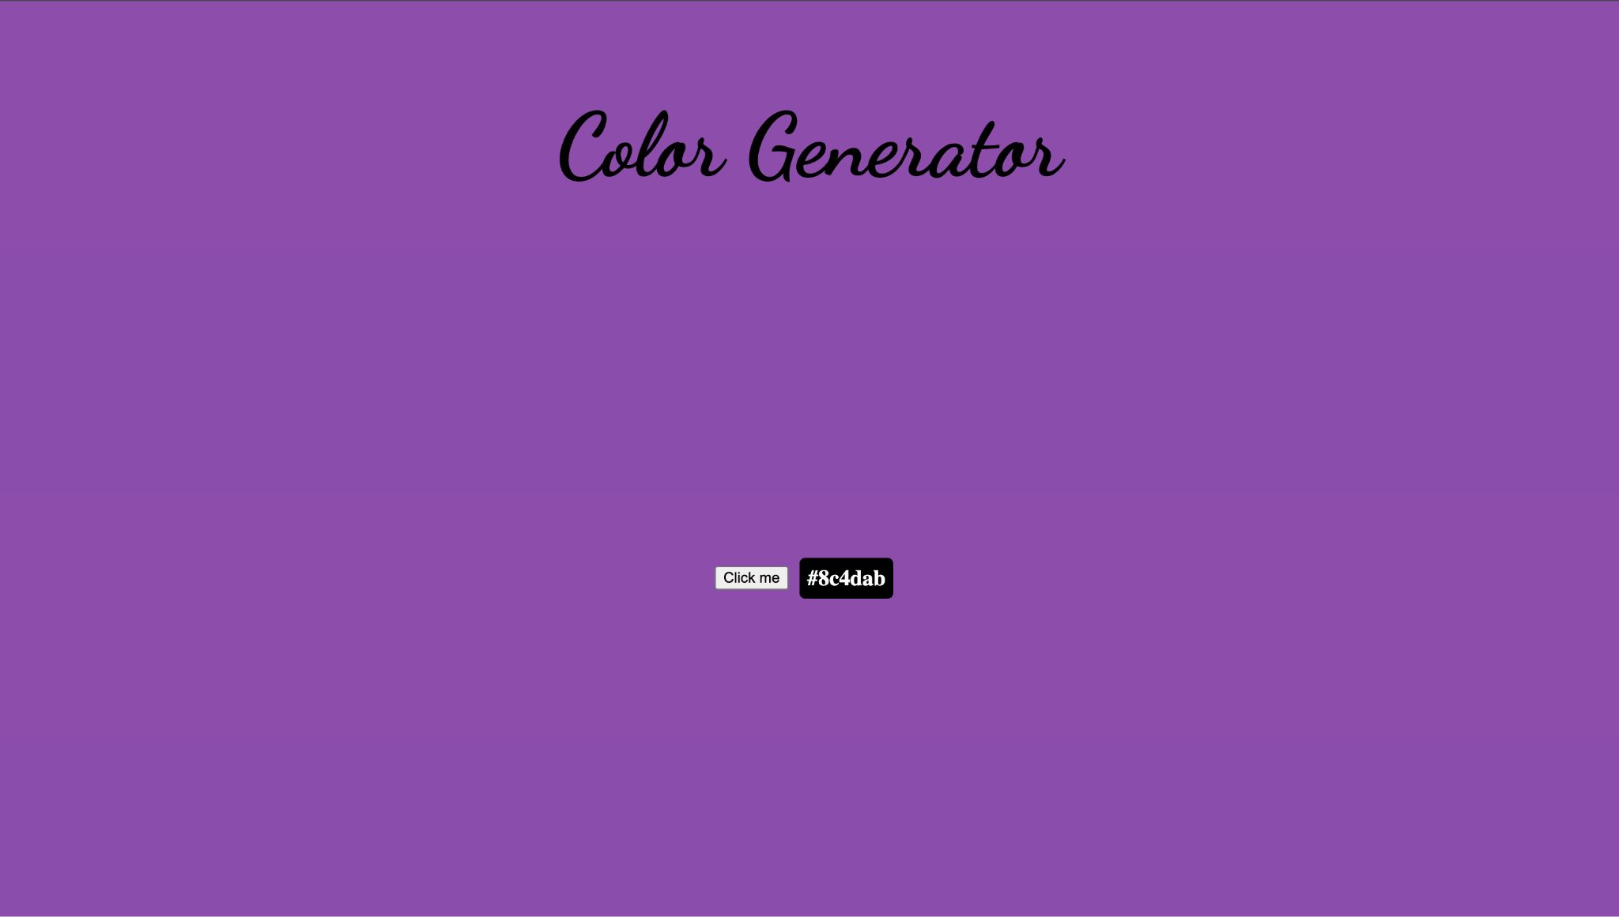

### **🧠 JavaScript Counter – 10 Smart Lessons**

1️⃣ **Why use a variable for the counter?** 📦 A variable allows you to store and manipulate the count logically in your JavaScript — instead of tying it directly to the UI. This separation of logic and presentation makes your code reusable and easier to maintain.

2️⃣ **How do addEventListener() or onclick work?** 🛎 These methods attach functions to events like button clicks. When the user interacts, the assigned function executes, enabling dynamic behavior in your app.

3️⃣ **What if you don’t update the DOM?** 🕳 The count might change in your script, but if you don’t reflect it in the DOM (e.g., using innerText), the user sees nothing. Updating the UI is essential to show changes.

4️⃣ **Why block negative counts?** 🚫 It improves user experience and mimics real-world limits — like preventing cart items from going negative or scores from dipping below zero.

5️⃣ **How to reset to zero?** 🔄 You can set the counter back to 0 using the same method as initialization, but the difference lies in when and how it gets triggered — like through a dedicated reset button.

6️⃣ **innerText vs textContent vs innerHTML** 🔍 All three can update the DOM, but they differ in performance and behavior:

* innerText respects styling and line breaks.
* textContent is faster and includes hidden content.
* innerHTML parses HTML tags — risky if handling user input.

7️⃣ **Why use named functions like increment()?** 🧩 Separating logic into clear, reusable functions makes your code easier to read, test, and debug. It’s a good habit for scalability.

8️⃣ **Best way to show feedback on value change?** 🎨 Combine JavaScript with CSS classes for visual effects — like flashing colors when values change or animating the number to highlight updates.

9️⃣ **What if 100 people click at once?** 🌐 In multi-user environments, frontend-only logic breaks down. You’ll need server-side logic or state management to handle concurrency properly.

🔟 **Persist the count after reload?** 💾 Use localStorage for simple apps or a backend/database if you need to share the value across users or devices.

📣 Built this as a learning aid —  
 #JavaScript #CodingProjects #MiniApps #DevCommunity

Just built a simple random background color generator using JavaScript! Here's how it works and what I learned 👇

<https://github.com/hitarth2123/SEM2/tree/main/Sprint2/Javascript%20/Day2/Project2>